RESPECTFUL - RESPONSIBLE - COURAGEOUS - KIND

ENROLMENTS ALWAYS WELCOME

NEWSLETTER

ISSUE 6 AUGUST 2025

Latest News
Reminders

Welcome Back
Welcome back to our students, families, staff, and the wider school community. I hope everyone enjoyed a restful and refreshing break. Term 3 is shaping up to be a busy and exciting one, packed with fantastic learning opportunities. It’s a shorter term, with only nine weeks, so be sure to take note of key dates such as SSGs and upcoming excursions.

SSGs (Student Support Group Meetings)
Our next round of SSGs will take place during the week of August 11–15. These meetings are a valuable opportunity to celebrate student progress, set new learning goals, and strengthen the partnership between home and school.

Students are always welcome to attend and take part in their meetings. Please contact the school to book a time that works for your family.

National Science Week 2025 National Science Week 2025 will run from August 12–20, with the theme “Decoding the Universe.” A highlight for our students will be the excursion to the Bendigo Discovery Science & Technology Centre, where hands-on activities will spark curiosity and encourage exploration of the mysteries of the universe.
THURSDAY 14TH AUGUST EXCURSION
- Bendigo Science Discovery & Technology Centre

Tuesdays 9.30-11.15am PLAYGROUP

Calendar Dates - 2025
Thurs 14th Aug - Science Week Excursion Fri 22nd Aug - Book Week Dress Up Day Thur 21st Aug - School Council Meeting Wed 3rd Sept - Family Maths Night (5pm
-7pm)
Sun 7th Sept - Fathers Day
Thur 12th Sept - School Council Meeting Fri 20th Sept - Last day of Term3 - 2.30pm finish
Contact Info
7 Parsell Road, Langley. Victoria 3444
Ph: 5423 4125 Fax: 5423 4211
Email: langley.ps@education.vic.gov.au
http://www.langleyps.vic.edu.au

LIKE US ON FACEBOOK

Langley Primary School acknowledges the history, culture, diversity, and value of all Aboriginal and Torres Strait Islanders, and pa ys respect to their elders past and present, as well as acknowledging future generations.
PAGE 01

Latest News Cont...

Book Week
Book Week will be celebrated from Monday, August 18 to Friday August 22. Our Book Week Dress-Up Day will be held on Friday, August 22. Students are encouraged to come dressed as a favourite book character. Start planning your costume now—there will be plenty of fun activities throughout the week to promote a love of reading!

Staff Professional Learning
On Tuesday, August 5 staff, including Trinity who is not in the photo, attended The Resilience Project Teacher Seminar—a powerful and inspiring professional learning event. The day explored key wellbeing pillars: emotional literacy, empathy, gratitude, and mindfulness. Staff gained practical strategies for embedding these concepts into everyday routines and discussed the importance of strong, positive relationships in building student resilience. These ideas will continue to shape our school-wide approach to wellbeing and guide our ongoing support
for students’ social and emotional development.

Pop-Up Playgroup – Tuesdays at School!
Our Pop-Up Playgroup is up and running again, offering a fun and welcoming space for children aged 0 to 6 years and their parents or carers.
Held on Tuesdays, the session includes a variety of engaging activities such as:
Story time and singalongs Musical instruments Playdough and foam mat play Outdoor games and active play

It’s a great way for little ones to play, learn, and connect — and for families to build friendships within our school community.

If you know someone who may be interested, please encourage them to contact Erica on 0408 484 066 for more information.
We’d love to see some new faces join the fun!

Enrolments Now Open for Foundation (Prep) 2025
Enrolments for Foundation (Prep) 2025 in Victorian government primary schools are now open. We are accepting enrolments for 2026.
To be eligible to start Foundation in 2025, children must turn 5 years old by April 30, 2025.

We are currently accepting enrolments for all year levels throughout the year. If you or someone you know has a child ready to start school, we welcome you to contact the school to arrange a tour. We have had some great success with part time enrolments and happy to tailor a transition program to suit the needs of your child.
Call us on 5423 4125 to book a visit or find out more.

Please help us spread the word within the community!

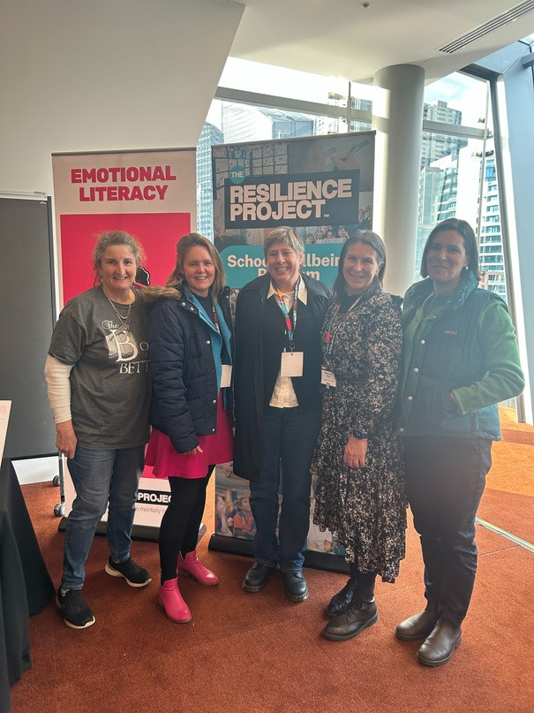Langley Primary School acknowledges the history, culture, diversity, and value of all Aboriginal and Torres Strait Islanders, and pa ys respect to their elders past and present, as well as acknowledging future generations.
PAGE 02

RESPECTFUL - RESPONSIBLE - COURAGEOUS - KIND

Latest News Cont...

Building Strong Mathematicians with Top Ten Maths
Last week, our teaching staff took part in an inspiring and highly valuable Professional Learning Day with Anna from Top Ten Maths. This hands-on session gave us the opportunity to deepen our understanding of the Top Ten Maths program—a research- based approach designed to build strong number sense and flexible problem-solving strategies.
Throughout the day, staff explored a range of practical resources and evidence-informed teaching practices that align with the Victorian Curriculum. A key focus was on using diagnostic data and formative assessment to target the specific learning needs of our students, helping ensure every child can experience success and growth in maths.
We are excited to embed these strategies into our everyday teaching and continue to build confident, capable mathematicians in every classroom.
Our students are already noticing the impact. Dusty shared, “I’m feeling medium about maths,” and we’re hopeful that with the new approaches, Dusty’s confidence will continue to grow. Pixie proudly reported, “Maths is going great! The teacher said you only have to do two [questions], but I wanted to do more— and I finished all of my work!”

To keep this momentum going and to celebrate maths in our school community, we’re excited to invite all families to our Family Maths Night on Wednesday 3rd September. This event will feature fun, hands-on maths activities, puzzles, and challenges designed to get families thinking, talking, and laughing together. It’s a great opportunity to engage with your child’s learning, promote positive attitudes towards maths, and explore how maths is used in everyday life.

Come along to join the fun and discover how enjoyable—and meaningful—maths can be when we work together!

Thank You to Our School Council
We’d like to extend a warm thank you to our dedicated School Council members for the important work they do in supporting the success of our school. Council members have recently undertaken training to further strengthen their understanding of governance and school operations, ensuring they can continue to make informed decisions that benefit our whole community. Being on School Council is a valuable way to contribute, learn new skills, and have a voice in shaping the direction of our school. If you are interested in joining school council, we have vacancies for a community member and a parent representative. Please see Frances if you are interested. Our next School Council meeting will be held on Thursday 21st August, and everyone is welcome to attend. Please RSVP to the office if you’d like to come along.

Greater responsibilities for school leaders
From term 3 2025, principals in Victoria will have expanded authority to suspend or expel students for serious behaviour that occurs beyond school grounds—including online or in public areas. This aims to ensure student safety and maintain a positive school climate

School uniform changes
In an effort to reduce costs for families, the Victorian government has announced that school logos will be banned on select uniform items starting next year. This measure is expected to make uniforms more affordable for parents

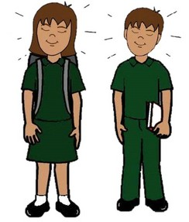Langley Primary School acknowledges the history, culture, diversity, and value of all Aboriginal and Torres Strait Islanders, and pa ys respect to their elders past and present, as well as acknowledging future generations.
PAGE 03

RESPECTFUL - RESPONSIBLE - COURAGEOUS - KIND

Photo Gallery

COMPOSTING INCURSION

On Monday 27th July we had a very special learning opportunity with James from the Victorian Schools Garden Program, who led us through a fascinating and hands-on session about composting and worm farming.
Joined by our friends from Redesdale Mia Mia Primary School, we dug deep into the science behind compost, exploring how balancing carbon and nitrogen layers creates a healthy, functioning system.
We then turned our attention to the world of composting worms—their homes (compost bins!), their role in breaking down waste, and how they help create rich, nutritious soil.
dents were thrilled to get up close with these incredible waste warriors and learn just how important they are to our environment.
A big thank you to Aga for organising such an enriching experience. Her passion, expertise, and dedication continue to be the driving force behind this engaging and valuable program that benefits our entire school community. We’re excited to continue our composting journey here at Langley—and look forward to seeing these sustainable practices take root at home too!

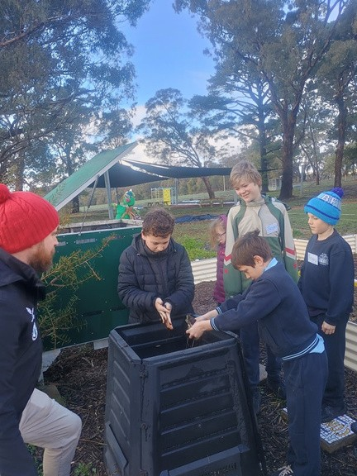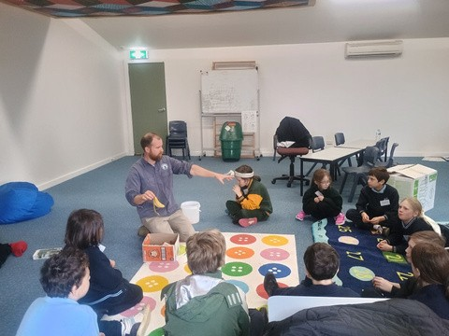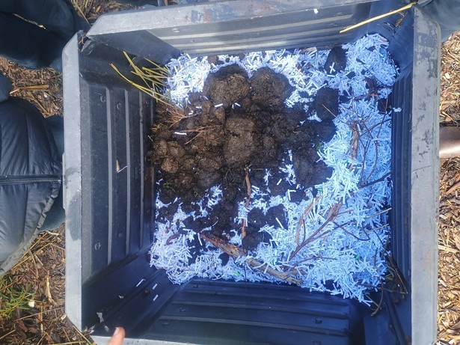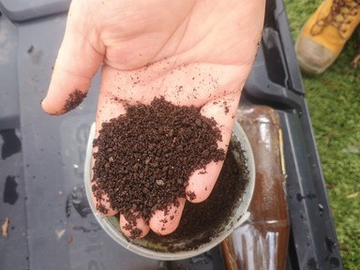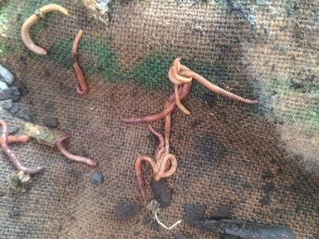
Langley Primary School acknowledges the history, culture, diversity, and value of all Aboriginal and Torres Strait Islanders, and pa ys respect to their elders past and present, as well as acknowledging future generations.

PAGE 03

RESPECTFUL - RESPONSIBLE - COURAGEOUS - KIND

Community News

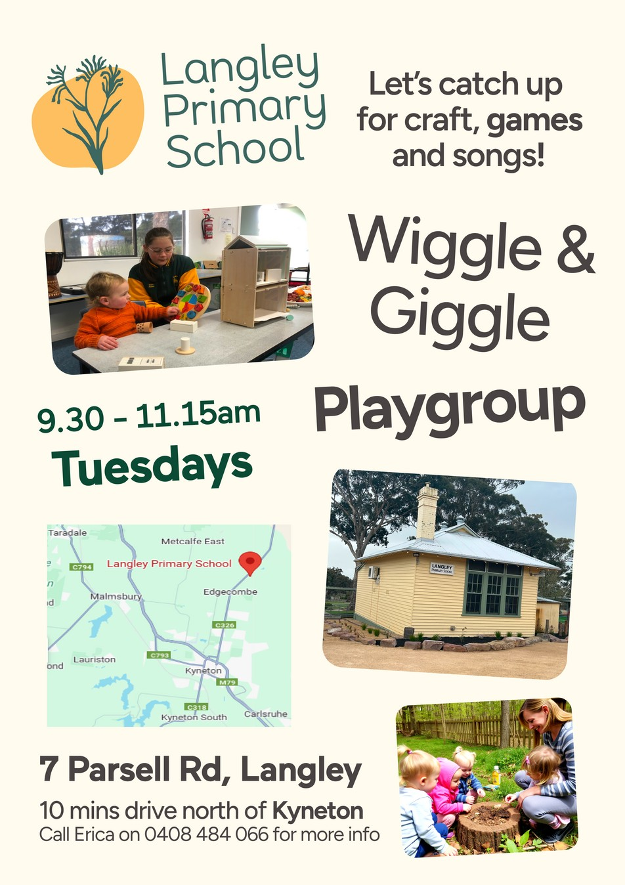

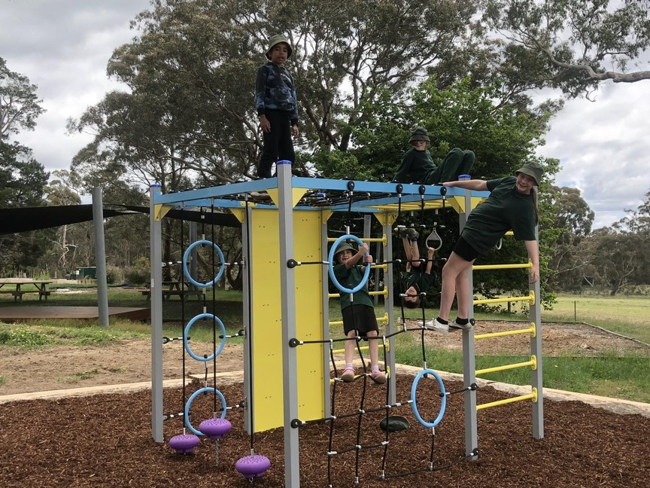Langley Primary School acknowledges the history, culture, diversity, and value of all Aboriginal and Torres Strait Islanders, and pa ys respect to their elders past and present, as well as acknowledging future generations.
PAGE 05

RESPECTFUL - RESPONSIBLE - COURAGEOUS - KIND

Community News

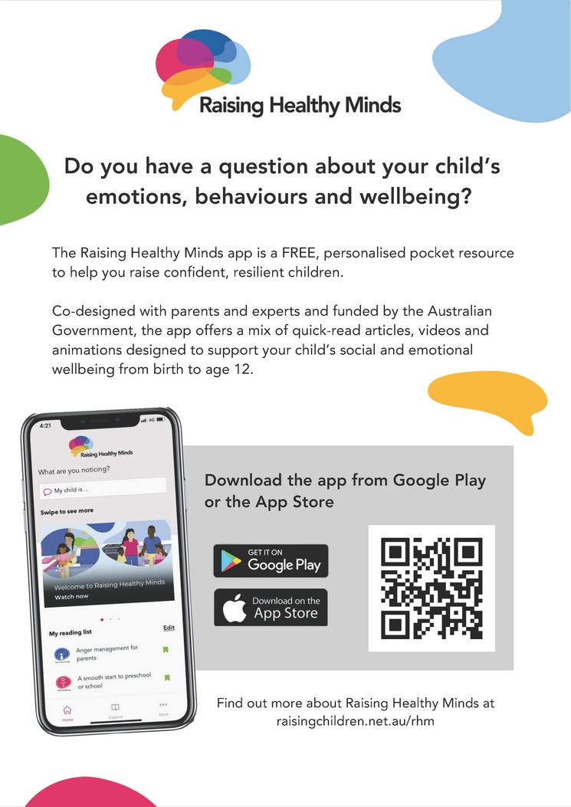
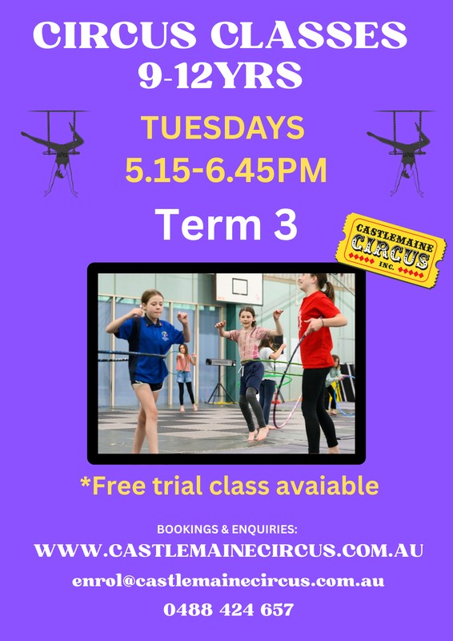
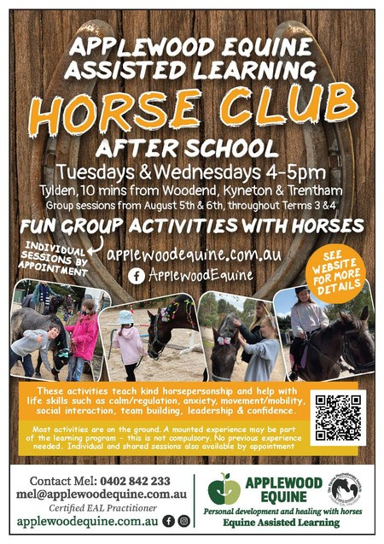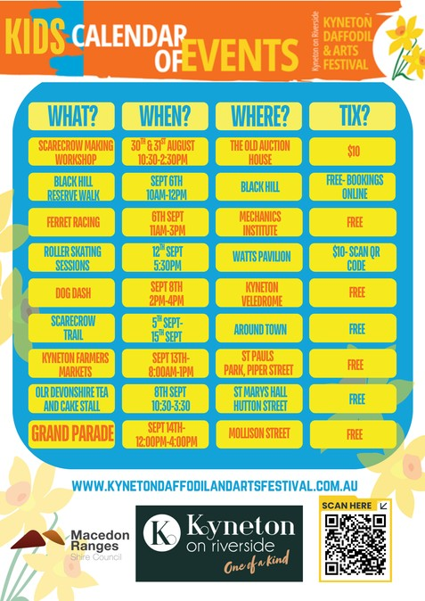

Langley Primary School acknowledges the history, culture, diversity, and value of all Aboriginal and Torres Strait Islanders, and pa ys respect to their elders past and present, as well as acknowledging future generations.
PAGE 06

RESPECTFUL - RESPONSIBLE - COURAGEOUS - KIND

Community News

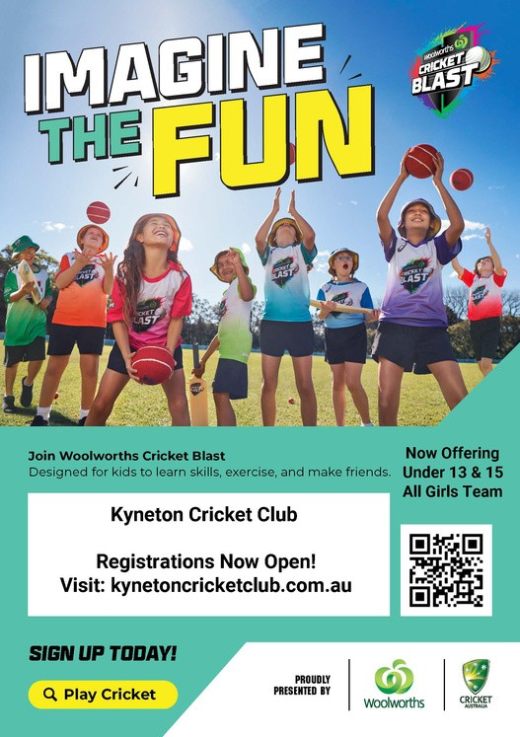
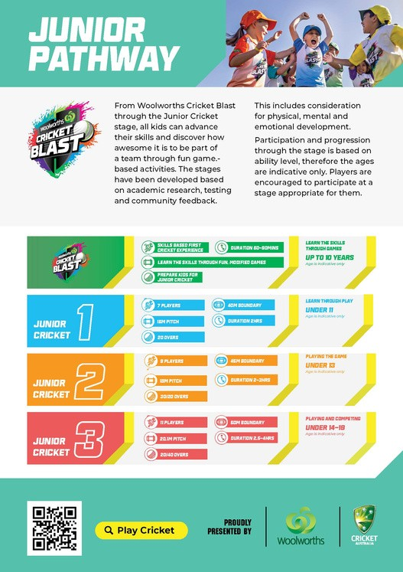
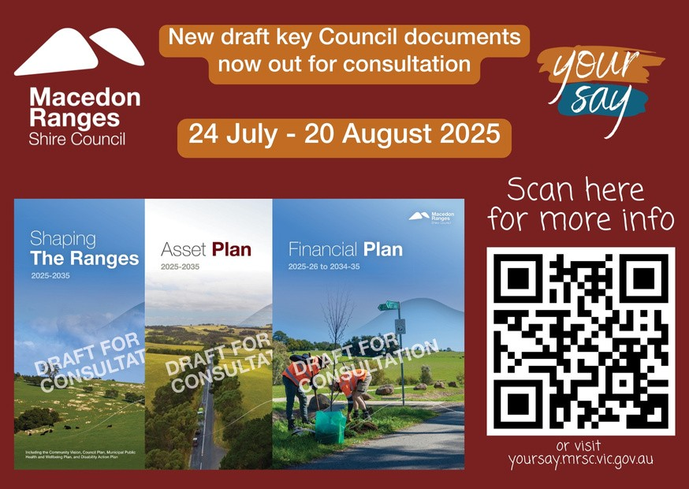

Langley Primary School acknowledges the history, culture, diversity, and value of all Aboriginal and Torres Strait Islanders, and pa ys respect to their elders past and present, as well as acknowledging future generations.

PAGE 07

RESPECTFUL - RESPONSIBLE - COURAGEOUS - KIND

Community News
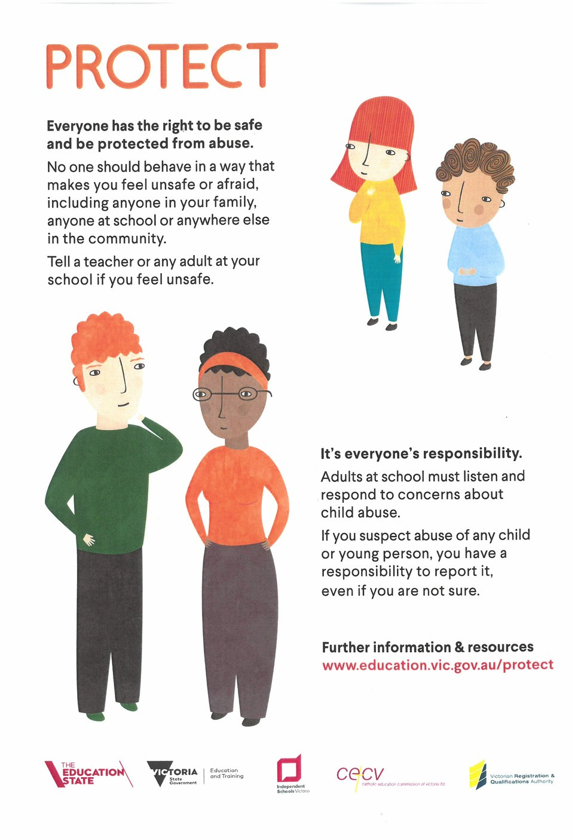

Langley Primary School acknowledges the history, culture, diversity, and value of all Aboriginal and Torres Strait Islanders, and pa ys respect to their elders past and present, as well as acknowledging future generations.
PAGE 08

